UNIT-1

CHAPTER 1.3

Lecture-3.5 (Comparisons)

Comparison Between Relational Algebra and Relational Calculus
Relational Algebra and Relational Calculus are the formal query languages for a relational model. Both form the base for the SQL language which is used in most of the relational DBMSs. Relational Algebra is a procedural language.
On the other hands, Relational Calculus is a declarative language. Relational Algebra and Relational Calculus can be further differentiated on many aspects, which I have discussed below with the help of comparison chart.
Relational Algebra is a procedural language that can be used to tell the DBMS how to build a new relation from one or more relations in the database and the Relational Calculus is a non-procedural language that can be used to formulate the definition of a relation in terms of one or more database relations.
While using the relational algebra, user has to specify what is required and what are the procedures or steps to obtain the required output whereas in Relational Calculus user just specifies what is required and need not to specify how to obtain it. Both the relational algebra and the relational calculus are formal, non-user-friendly languages. They have been used as the basis for other, higher-level Data Manipulation Languages (DMLs) for relational databases. They illustrate the basic operations required of any DML and serve as the standard of comparison for other relational languages.
The relational algebra is a theoretical language with operations that work on one or more relations to define another relation without changing the original relation(s). Thus, both the operands and the results are relations, and so the output from one operation can become the input to another operation. This allows expressions to be nested in the relational algebra, just as we can nest arithmetic operations. This property is called closure: relations are closed under the algebra, just as numbers are closed under arithmetic operations.
There are many variations of the operations that are included in relational algebra. Codd originally proposed eight operations, but several others have been developed. The five fundamental operations in relational algebra, Selection, Projection, Cartesian product, Union and Difference, perform most of the data retrieval operations, which can be expressed in terms of the five basic operations.
In relational algebra each operation takes one or more relations as its operand(s) and another relation as its result. Consider an example of mathematical algebra as shown below
3+5=8
Here, 3 and 5 are operands and + is an arithmetic operator which gives 8 as the result.
Similarly, in relational algebra, RI + R2 = R3
Here RI, R2 are relations (operands) and + is relational operator which gives R3 as a resultant relation.
Relational Algebra defined by using the eight basic operators, Codd then went on to define a Relational Calculus. Here, is a comparison of Relational Algebra and relational Calculus:
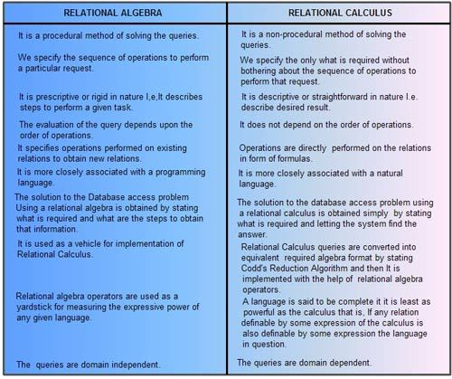

Difference between Tuple Relational Calculus (TRC) and Domain Relational Calculus (DRC)
1. Tuple Relational Calculus (TRC) :
A tuple relational calculus is a non procedural query language which specifies to select the tuples in a relation. It can select the tuples with range of values or tuples for certain attribute values etc. The resulting relation can have one or more tuples.
Notation :
{T | P (T)} or {T | Condition (T)}
-where T is resulting tuples and P(T) is a condition used to fetch T.
Example :
{T | EMPLOYEE (T) AND T.DEPT_ID = 10}
This select all the tuples of employee name who work for Department 10.
2. Domain Relational Calculus (DRC) :
A domain relational calculus uses list of attribute to be selected from the relation based on the condition. It is same as TRC, but differs by selecting the attributes rather than selecting whole tuples.
Notation :
{ a1, a2, a3, ..., an | P (a1, a2, a3, ..., an) }
-Where a1, a2, a3, … an are attributes of the relation and P is the condition.
Example :
{ | < EMPLOYEE > DEPT_ID = 10 }
select EMP_ID and EMP_NAME of employees who work for department 10.

Difference
Domain Relational Calculus - In contrast to tuple relational calculus, domain relational calculus uses a list of attribute to be selected from the relation based on the condition. It is same as TRC, but differs by selecting the attributes rather than selecting whole tuples.
Tuple Relational Calculus - A tuple relational calculus is a non procedural query language which specifies to select the tuples in a relation. It can select the tuples with range of values or tuples for certain attribute values etc. The resulting relation can have one or more tuples.

OTHER REFRENCES
- What are Relational Algebra and Relational Calculus? - Computer Notes (ecomputernotes.com)
- Introduction to Relational algebra & Relational calculus (beginnersbook.com)
- database - What is TRC and DRC in DBMS? - Stack Overflow

SUGGESTED BOOK REFERENCES
- C.J.Date, “An Introduction to DatabaseSystems”, Addison Wesley.
- Thomas M. Connolly, Carolyn & E.Begg,“Database Systems: A Practical Approach to Design, Implementationand Management”, 5/E, University of Paisley, Addison-Wesley.
- Rob,”Database Principal Fundamental Design, Cengage Learning.

